**RAA LUNCHEON**



Brigadier D. I. Perry OAM RFD ED in conjunction with the Royal Australian Artillery Association (Vic) Inc cordially invites both serving and retired Gunners to the Annual Royal Australian Artillery Luncheon.

This is a great opportunity to catch up and renew friendships with other Gunners, and especially to reunite those Gunners that we have not seen for a number of years.

The RAA Luncheon has been very successful over the past few years, so Gunners please bring along another Gunner to the Luncheon. WW2 Veterans are also welcome to attend at a reduced cost

**WHEN**: Wednesday 4th March 2020

**TIME:** 1200 for 1230 hours

**WHERE**: RACV Club, 501 Bourke St. Melbourne

**COST:** $75.00 (2 Course meal which includes a complimentary drink)

**DRESS:** Jacket and tie

**RSVP:** 21st February, 2020

**TO:** Reg W Morrell

Post Office Box 343, Mentone 3194.

Mobile – 0425 837 958

Email- regwmorrell@gmail.com

Direct Banking:

BSB 063 133 Account 00906918

(Please use surname as reference)

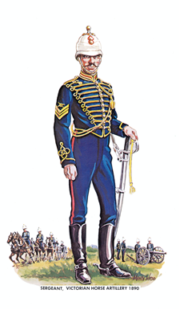

**-----------------------------------------------------------------Reply slip------------------------------------------------------------**

RANK...................................................... NAME:............................................................................................

ADDRESS........................................................................................................................................................

Tel.No............................................................................................................................................................

Additional Attendee…Rank.................................Name.......................................................................

Additional Attendee…Name……….......................................................................Rank..................................

Enclosed is a cheque for $.................(payable to RAA Association) ..**OR** tick circle if bank transfer done⃝

Special dietary requirements .......................................................................................................................

If possible, I wish to be seated near .............................................................................................................