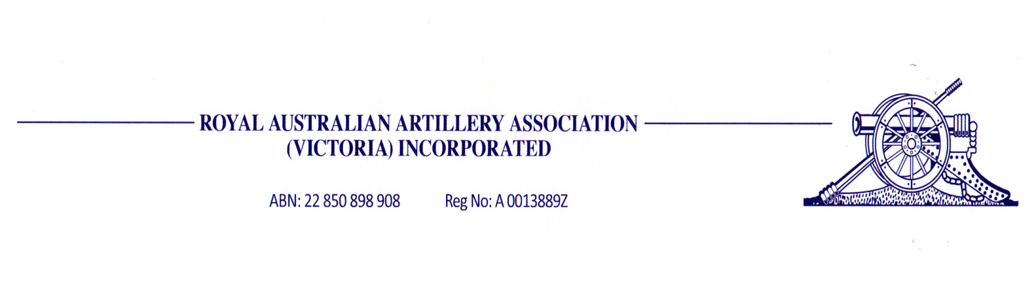
NOMINATION FORM

This form is to reach the Secretary no later than 30th November 2018

<……………………………………………………..…….> (full name) of

<…………………………………………………………………………..> (address)

Being a financial member of the Association, is hereby nominated for the position of President / Vice President / Secretary / Treasurer / Committee member (cross out those positions not nominated for) by the undermentioned Proposer and Seconder, who are also financial members of the Association.

<…………………..……………………> (signature of Proposer)

<……………………………………………………..> (Proposer’s full name)

<……………………..………………….> (signature of Seconder)

<……………………………………………..………> (Seconder’s full name)

Signature of consenting nominee: <………………………………………………>

FORM OF APPOINTMENT OF PROXY

I, <…………………………………………………..……………>

of <………………………………………………………………………………….>

being a member of the Royal Australian Artillery Association (Victoria) Inc, hereby appoint

<………………………………………….……….>

of <………………………………………………………………..>, being a member of that Incorporated Association, as my Proxy to vote for me on my behalf at the Annual General Meeting of the Incorporated Association to be held on 2nd December 2018, and at any adjournment of that meeting.

Signed <………………………….……….> Date <……………….>

Postal: PO Box 125 Email: justnotime2007-raa@yahoo.com.au Patterson Lakes Vic 3197 Web: http://www.artilleryvic.org.au

